PROGRAM 1: PROLOG PROGRAM FOR COLLEGE KNOWLEDGE

class(fy,it).

class(sy,it).

class(ty,it).

college(rscoe).

city(rscoe,pune).

state(rscoe,mh).

branch(it,rscoe).

branch(cs,rscoe).

branch(etc,rscoe).

branch(civil,rscoe).

branch(mech,rscoe).

subject(fy,cpp).

subject(sy, ds).

subject(ty, al).

location(X,Y):-city(C,X), state(C,Y).

learns(X,Y):- class(C,X), subject(C,Y).

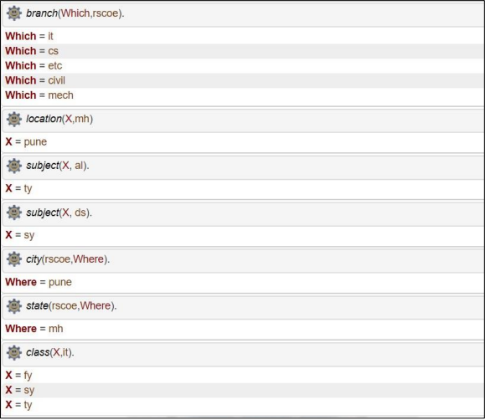

PROGRAM 2: PROLOG PROGRAM FOR RELATIONS KNOWLEDGE

parent(x,y).

parent(z,x).

child(X,Y):-parent(Y,X).

grandparent(Z,Y):-parent(Z,X),parent(X,Y).

friend(p,y).

friend(X,Y):-friend(Y,X).

likes(p,sing).

likes(y,cricket).classmates(p,y).

classmates(X,Y):-classmates(Y,X).

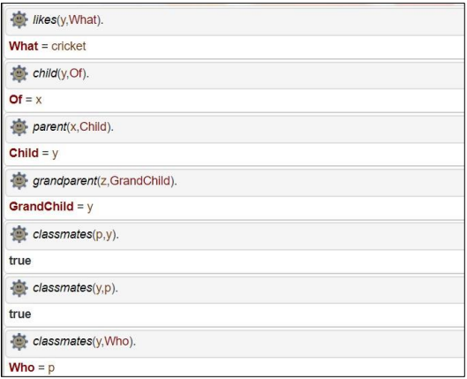

PROGRAM 3: PROLOG PROGRAM FOR TEACHER STUDENT KNOWLEDGE

studies(charlie, csc135).

studies(olivia, csc135).

studies(jack, csc131).

studies(arthur, csc134).

teaches(kirke, csc135).

teaches(collins, csc131).

teaches(collins, csc171).

teaches(juniper, csc134).

professor(X, Y) :- teaches(X, C), studies(Y, C).

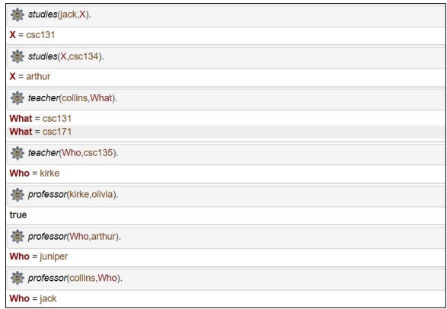

PROGRAM 4: PROLOG PROGRAM FOR MIN MAX

find_max(X,Y,X):-X>Y , ! .

find_max(X,Y,Y):-Y>X.

find_min(X,Y,X):-X<Y,!.

find_min(X,Y,Y):-Y<X.

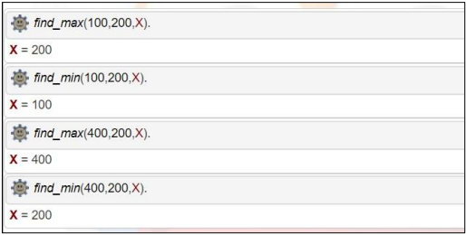

PROGRAM 5: PROLOG PROGRAM FOR BIKES

bike(ktm).

bike(bike1).

bike(bike2).

bike(bike3).

location(bike1,city1).

location(bike1,city2).

location(bike2,city2).

location(bike3,city3).

category(bike1,electric).

category(bike2,petrol).

category(bike3,pertol).

price(bike1,80000).

price(bike2,70000).

price(bike3,60000).

find_max(A,B,A):-price(A,X),price(B,Y),X>=Y, ! .

find_max(A,B,B):-price(A,X),price(B,Y),Y>X.

find_min(A,B,A):-price(A,X),price(B,Y),X<Y, ! .

find_min(A,B,B):-price(A,X),price(B,Y),Y<X.

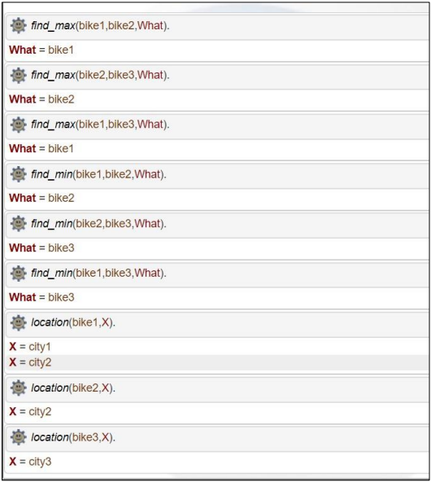

======================BFS=====================================

#include<iostream>

#include<map>

#include<queue>

#include<list>

using namespace std;

template <typename T> /*generic type , template class

to work with graph of integers or variables */

class Graph{

map<T, list<T>> l; //map<int,list<int>> // 2->(1,0,3)

public:

void addEdge(int x, int y){ //edges are bi-directional //Adds a new element at the end of the vector, after its current last element

l[x].push_back(y);

l[y].push_back(x);

}

void bfs(T src){

map<T,int> visited; //we created visited array

queue<T> q;

q.push(src);

visited[src]=true;

while(!q.empty()){

T node = q.front();

q.pop();

cout<<node<<" ";

for(auto nbr : l[node])

{

if(!visited[nbr]){

q.push(nbr);

//mark that nbr as visited

visited[nbr]= true;

}

}

}

}

};

int main()

{

Graph<int> g;

g.addEdge(0,1);

g.addEdge(1,2);

g.addEdge(2,3);

g.addEdge(3,4);

g.addEdge(4,5);

g.addEdge(3,0);

g.bfs(0);

return 0;

}

=====================================DFS=====================================

#include<iostream>

#include<map>

#include<queue>

#include<list>

using namespace std;

template <typename T>

class Graph

{

map<T,list<T>> l; //auxiliary

public:

void addEdge(int x,int y)

{

l[x].push_back(y);

l[y].push_back(x);

}

void dfs_helper(T src , map<T,bool> &visited)

{

cout<<src<<" ";

visited[src]=true;

for(T nbr:l[src])

{

if(!visited[nbr])

{

dfs_helper(nbr,visited);

}

}

}

void dfs(T src)

{

map<T,bool> visited;

for(auto p:l)

{

T node = p.first;

visited[node]=false;

}

dfs_helper(src,visited);

}

};

int main()

{

Graph <int> g;

g.addEdge(0,1);

g.addEdge(1,2);

g.addEdge(2,3);

g.addEdge(3,4);

g.addEdge(4,5);

g.addEdge(3,0);

g.dfs(0);

}

=================================best===================================

#include <bits/stdc++.h>

using namespace std;

typedef pair<int, int> pi;

vector<vector<pi> > graph;

// Function for adding edges to graph

void addedge(int x, int y, int cost)

{

graph[x].push_back(make_pair(cost, y));

graph[y].push_back(make_pair(cost, x));

}

// Function For Implementing Best First Search

// Gives output path having lowest cost

void best_first_search(int source, int target, int n)

{

vector<bool> visited(n, false);

// MIN HEAP priority queue

priority_queue<pi, vector<pi>, greater<pi> > pq;

// sorting in pq gets done by first value of pair

pq.push(make_pair(0, source));

int s = source;

visited[s] = true;

while (!pq.empty()) {

int x = pq.top().second;

// Displaying the path having lowest cost

cout << x << " ";

pq.pop();

if (x == target)

break;

for (int i = 0; i < graph[x].size(); i++) {

if (!visited[graph[x][i].second]) {

visited[graph[x][i].second] = true;

pq.push(make_pair(graph[x][i].first,graph[x][i].second));

}

}

}

}

// Driver code to test above methods

int main()

{2

// No. of Nodes

int v = 14;

graph.resize(v);

// The nodes shown in above example(by alphabets) are

// implemented using integers addedge(x,y,cost);

addedge(0, 1, 3);

addedge(0, 2, 6);

addedge(0, 3, 5);

addedge(1, 4, 9);

addedge(1, 5, 8);

addedge(2, 6, 12);

addedge(2, 7, 14);

addedge(3, 8, 7);

addedge(8, 9, 5);

addedge(8, 10, 6);

addedge(9, 11, 1);

addedge(9, 12, 10);

addedge(9, 13, 2);

int source = 0;

int target = 9;

// Function call

best_first_search(source, target, v);

return 0;

}

=====================water jug========================

#include<bits/stdc++.h>

using namespace std;

int x;

int y;

void show(int a, int b);

int min(int w, int z)

{

if (w < z)

return w;

else

return z;

}

void show(int a, int b)

{

cout << setw(12) << a << setw(12) << b<<endl;

}

void s(int n)

{

int xq = 0, yq = 0;

int t;

cout << setw(15) <<"FIRST JUG"<< setw(15) <<"SECOND JUG"<<endl;

while (xq != n && yq!=n )

{

if (xq == 0)

{

xq = x;

show(xq, yq);

}

else if (yq == y)

{

yq = 0;

show(xq, yq);

}

else

{

t = min(y - yq, xq);

yq= yq + t;

xq = xq - t;

show(xq, yq);

}

}

}

int main()

{

int n;

cout << "Enter the liters of water required out of the two jugs: ";

cin >> n;

cout << "Enter the capacity of the first jug: ";

cin >> x;

cout << "Enter the capacity of the second jug: ";

cin >> y;

if(n<x || n<y)

{ if(n%(__gcd(x,y))==0)

s(n);

else

cout<<"This is not possible....\n";

}

else

cout<<"This is not possible....\n";

}

================travelling salesman===================

#include <iostream>

using namespace std;

int array[5][5],visited[5],n,cost=0;

int findSmallest(int c){

int nc=99999;

int min=99999, city_min;

for(int i=0; i < n; i++){

if((array[c][i]!=0) && (visited[i] == 0)){

if(array[c][i]+array[i][c] < min){

min=array[i][0]+array[c][i];

city_min=array[c][i];

nc=i;

}

}

}

if(min!=99999)

cost+=city_min;

return nc;

}

void totalCost(int city){

int ncity;

visited[city]=1;

cout<<city+1<<" --> ";

ncity = findSmallest(city);

if(ncity==99999){

ncity=0;

cout<<ncity+1;

cost+=array[city][ncity];

return;

}

totalCost(ncity);

}

int main(){

cout<<"\nEnter the number of cities : ";

cin>>n;

for(int i=0; i < n; i++){

cout<<"\nEnter Elements of Row :"<<i+1;

for(int j=0; j < n; j++){

cout<<"\nEnter Elements from "<<i+1<<" to "<<j+1<<" : ";

cin>>array[i][j];

}

visited[i]=0;

}

cout<<"\n\nThe cost list is:";

for(int i=0;i < n;i++){

cout<<"\n";

for(int j=0;j < n;j++){

cout<<array[i][j]<<"\t";

}

}

cout<<"\n\nThe Path is : \n";

totalCost(0);

cout<<"\n\nTotal cost is : "<<cost;

return 0;

}